Analysis and data curation :

15:19 : Deleted 12:43 time stamp of GRASNEW 0 degree plyabck angle because there was an error in the gain settings .

15:32 : the empty and w ball readings are a saturated !! ..careful next time at 30dB Fireface gain.

16:36 : it seems like for the 30 degrees and so on – the speaker directionality means that not too much ultrasound reaches so far away – and therefore the power spectra look so similar

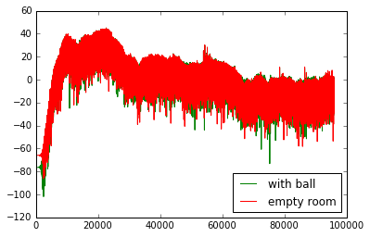

Figure from recording w SANKEN, same data w GRAS too

But when we look at 180 degrees for instance - since the speaker is so directional – the recording at 180 degrees is actually really nice… and there’s a drop of -8 dB rms because of the ball’s blocking effect.

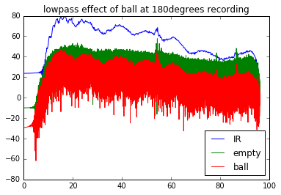

Figure recording w SANKEN, similar recording also w GRAS

At other recording spots behind the ball – the speaker’s directionality limits the target strength measurements again… w just a -0.09 dB rms difference

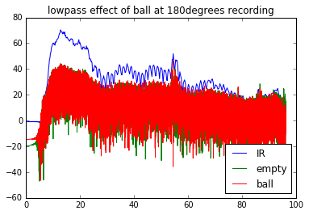

Figure w new GRAS mic - recorded at 120 degrees

At 90 degrees however….

18:04 …. How to solve the issue right now .. listed in no particular order of priority …

1. The probe noise signal is not fine, it’s still not flat enough …
2. The mics at 1m are too far away to record anything perceptible
3. The mics at 1m are placed at some kind of weird distance which causes destructive interference
4. Maybe understand what is happening with single frequency ultrasound playbacks at 55 KHz or something ?..
5. Keep microphone closer to bat and see if anything better is recorded ? at ½ meter perhaps ?
6. Keep speaker closer to bat .. and check how that changes things ?.. but this will also affect the spatial uniformity with which the bat is being ensonified… check out the previous round of data..why this 5 degree number ?..which then decided the 2m distance to the bat ?...
7. Use the new GRAS mic ….saves you the doubt of whether the old one is well calibrated or not …